Lunching the Monolithic Website on an EC2 Instance using the User Data
Lunch the EC2 Instance Using the instance name and Instance AMI.
- Click on Lunch Instance
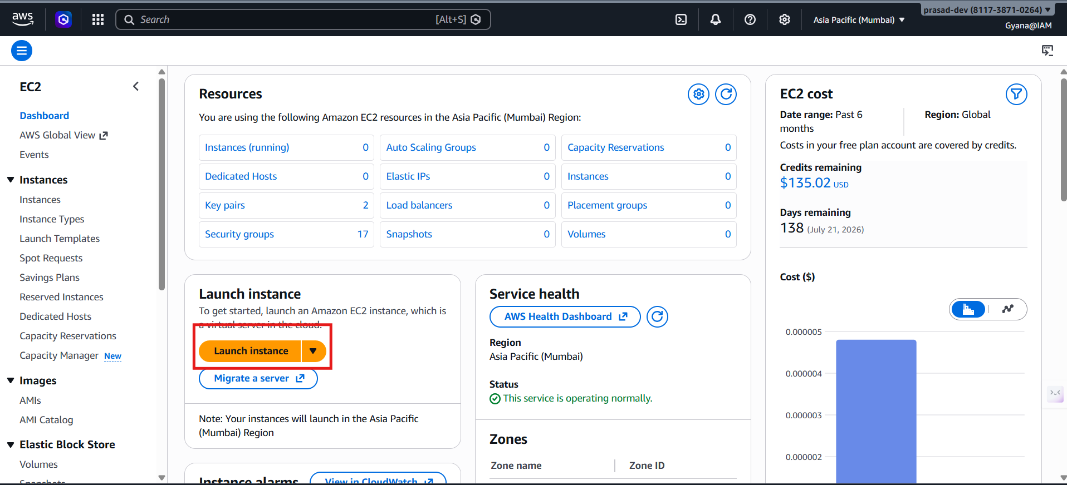
- Give the name and use Amazon Linux
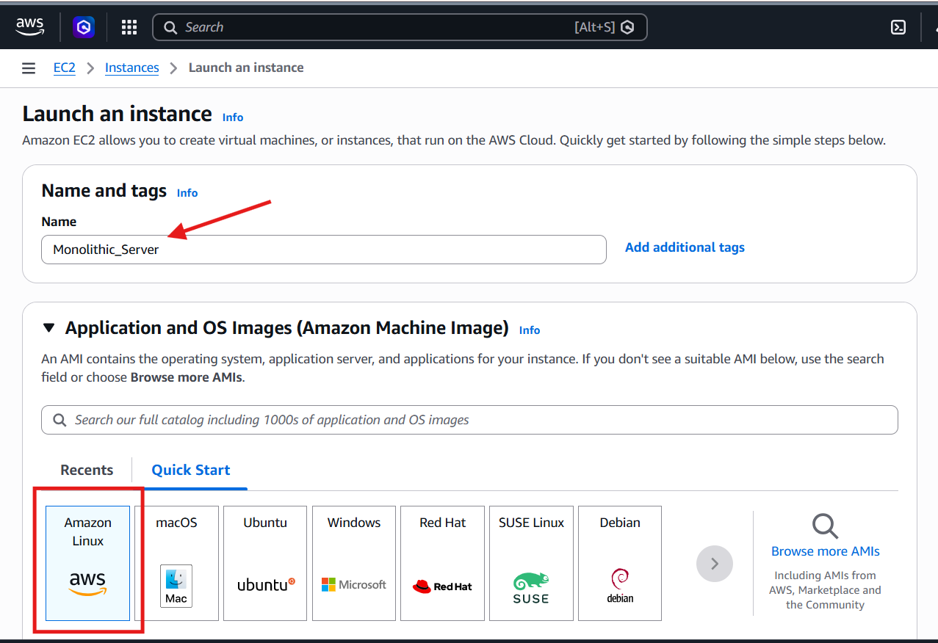
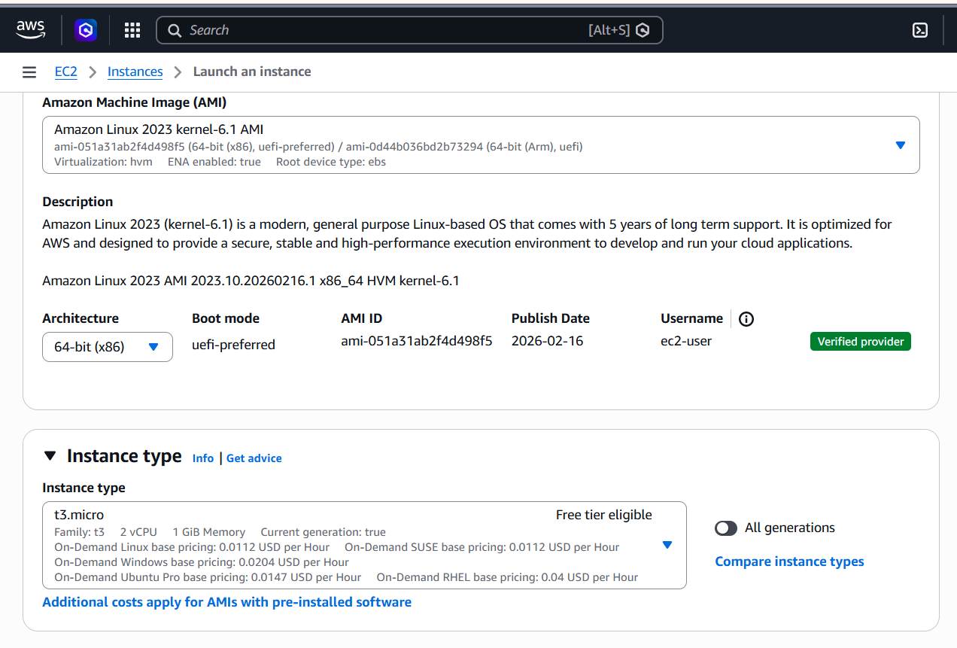
Use the Private Key
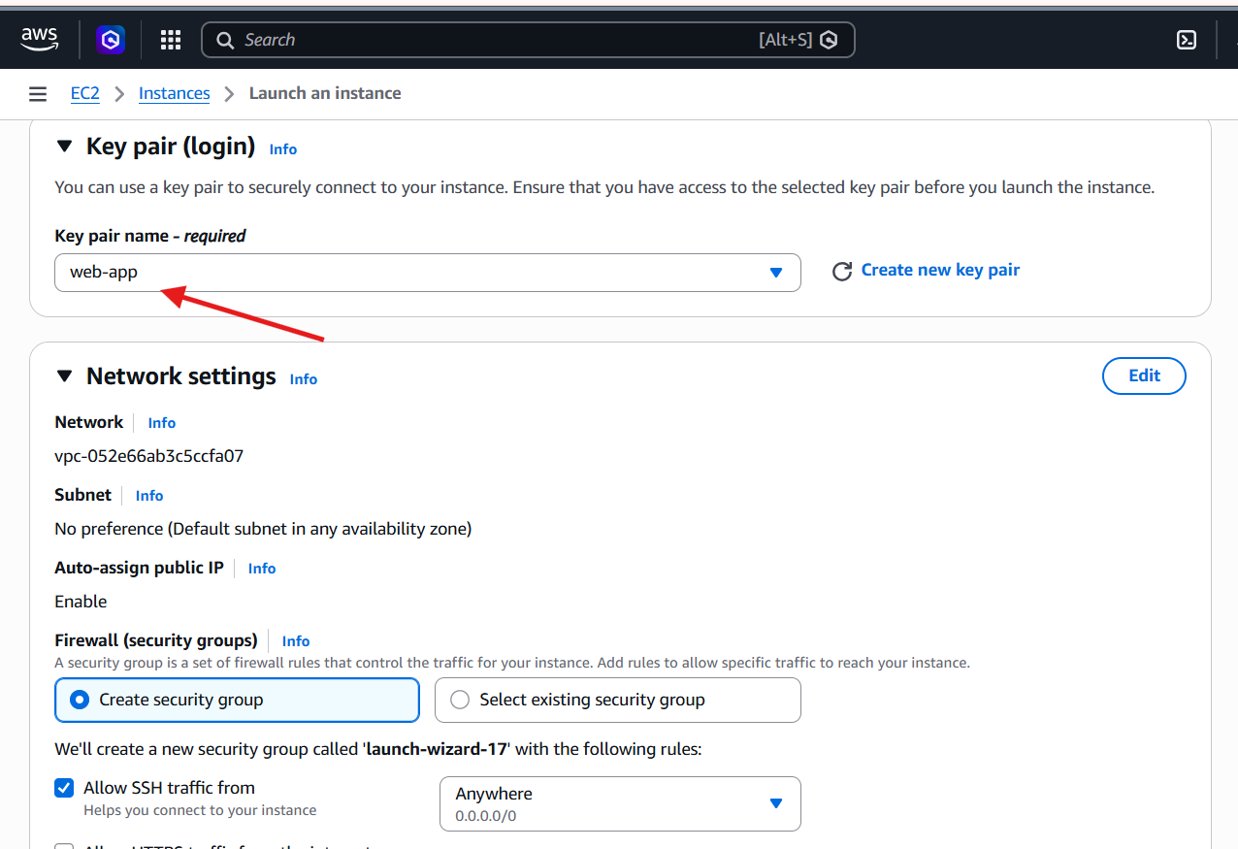
Allow the HTTP traffic from the internet.
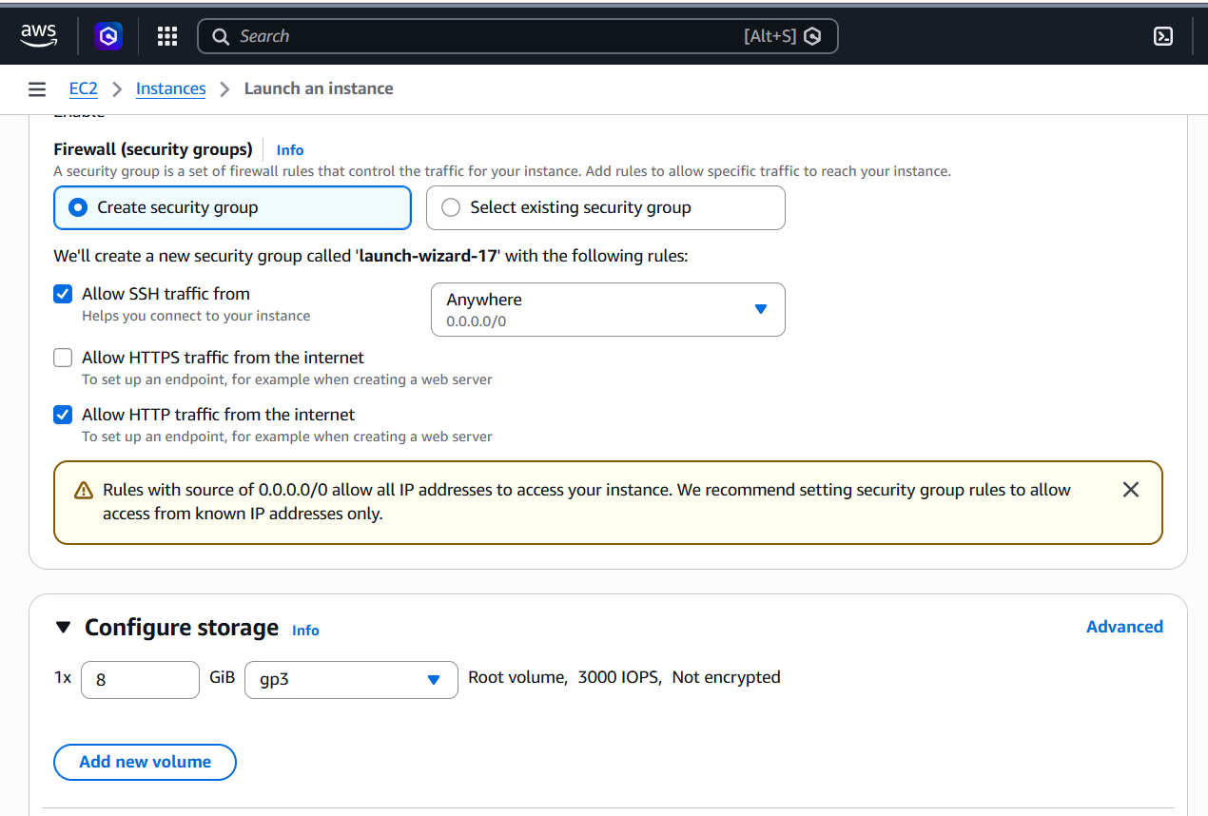
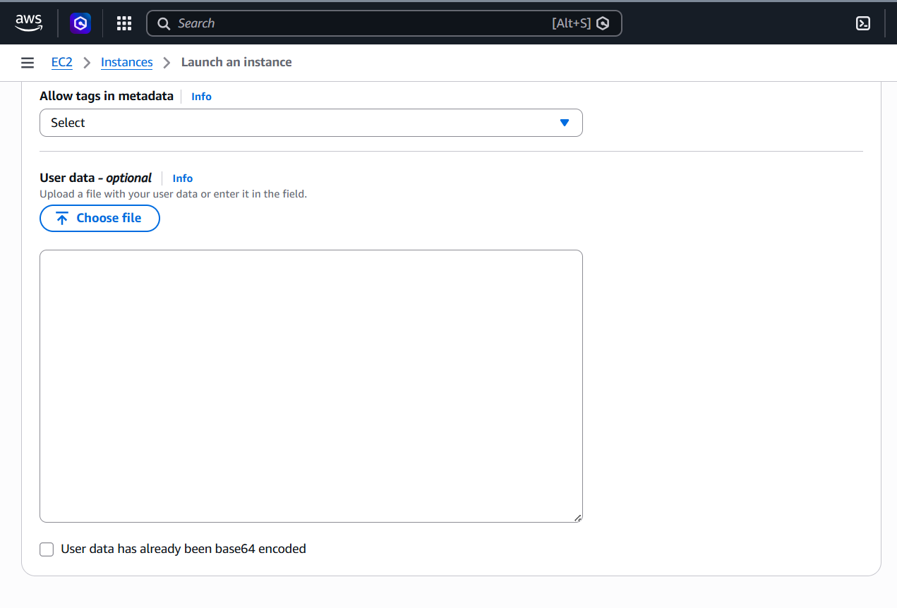

Enter the required data inside the User-data section.
- Here I am using the yum for installation because I am using the Amazon Linux.
- echo is for accessing.
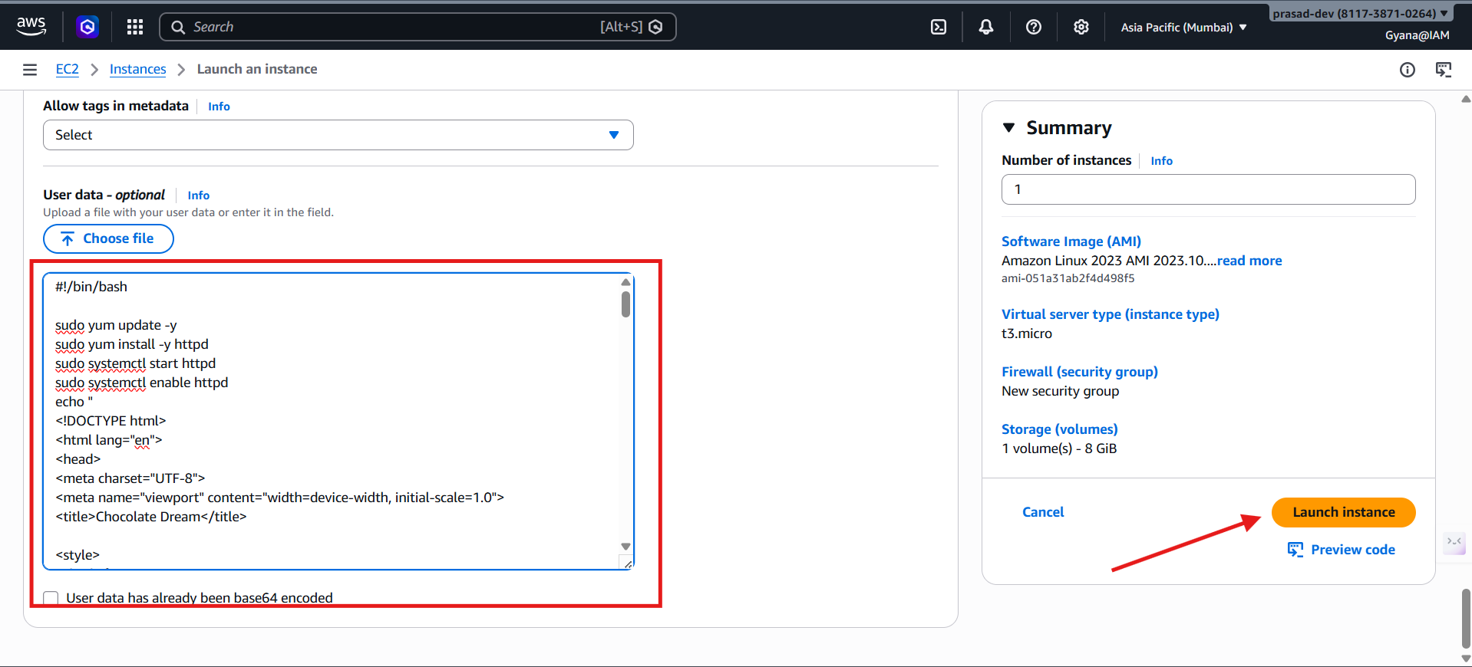
- Use the Public Ip and the port 80 to access the Monolithic web site.
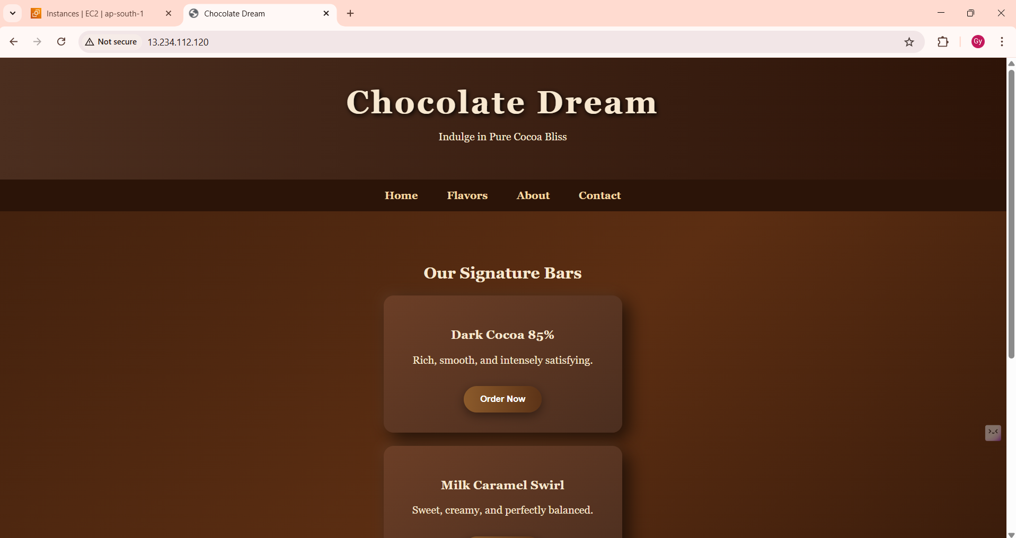

Adding the required data inside the User data section and lunched 3 EC2 instance and then access the Monolithic website.

-Monolithic site 2
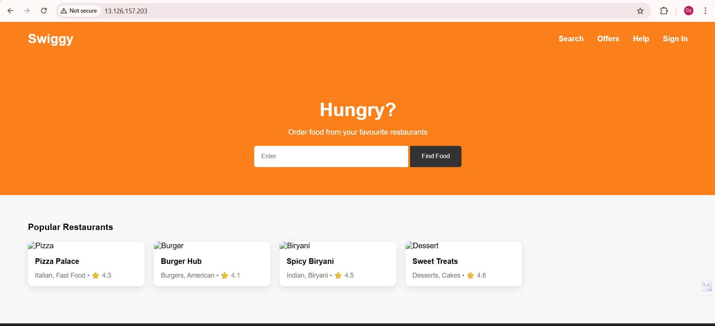
Monolithic Site 3
